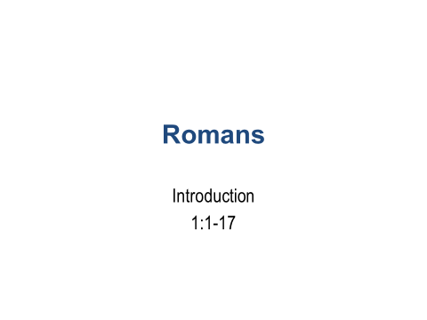

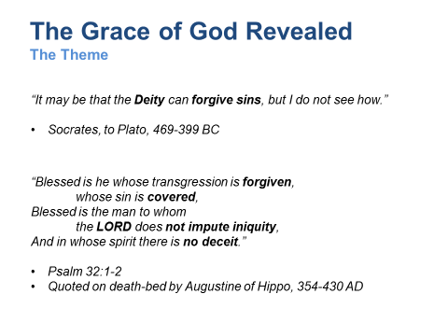

*“It may be that the* ***Deity*** *can* ***forgive******sins****, but I do not see how.”*

*Socrates, to Plato, 469-399 BC*

*God’s greatest problem:*

* + *To compromise His hatred of sin would be to compromise His character.*
  + *How does a Just God justify sinful man?*
  + *How can God permit man to enjoy the destiny originally prepared for him?*

GRACE: Profound in meaning.

Eph. 2:8 “For by grace you have been saved through faith, and that not of yourselves; it is the gift of God, not of works, lest anyone should boast.

Romans displays:

* God’s righteousness
* Our iniquity, and
* God’s remedy through Grace

Questions:

1. What is the connection between Grace, Faith, and Works?
2. Are we “saved” by Grace alone? What about Mark 16:16; Acts 2:38…?

God’s Grace relates to a *type* of Faith that *calls for action*. God deals in reality according to His character. He desires and requires obedience in response to His Holiness (Hosea 6:6, Matthew 7:21). Believers receive a Righteousness imputed (2 Cor. 5:21).

**Psalms 32:1-2**

* “…there is no deceit”… *honest with others and with oneself.*
* “…does not impute iniquity”…. *conveys righteousness*.

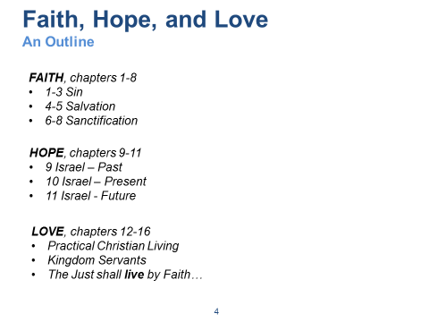

Chapters 1-3 – Establishing the Situation, Problem, and Implications, leading to a Needs Analysis.

* We are all part of a fallen race. But, God’s Truth is evident to all.
  + CH1: Pagan or Natural Man – Evidence from Creation enough. Guilty!
  + CH2: Moral Man – Doesn’t live-up to his own conscience. Guilty!
  + CH3: Spiritual Man – Commitment and sincerity are flawed. Guilty!
* God’s Truth encompasses The Elements of Reality
  + Origins
  + Meaning
  + Morality
  + Destiny

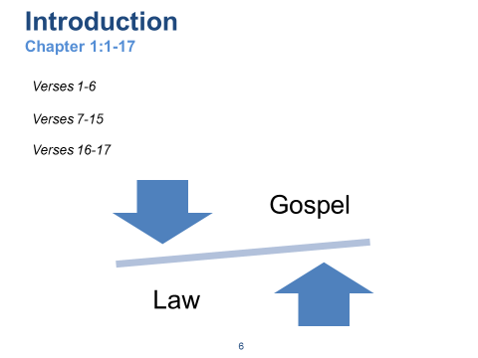

Verses 1-6

* v2 - Gospel of God; see 1 Cor. 15:1-4; **establishing link to OT** ; Gospel is of a **Person - Jesus**
* v3 – Prophetic validation of Him; see 2 Peter 1:19-21; made of the seed of David (flesh); declared to be the Son (power)
* v4 – **Confirmed to be the Messiah** by predicted and factual Resurrection from death; see **Acts 2:22-36**
* v5 – Through Him; for His name; see Acts 2:21,22,32,36 **Acts 4:12**
* v6 – Called ; see **Gal. 3:24-29**

Verses 7-15

* v7 – Saints “holy”; see Gal. 3:24-29
* v8 – Must’ve thrilled the hearer in Rome; they’ve heard of our **Faith** (what sets Christianity apart?)
* v9 – Not saying this lightly; **serving with his spirit – a fulltime thing**; being real/honest; coming from the depths of his spirit
* v10 – Expressing his desire to come there an become a part of their lives
* v11,12 – Share in the ministry; **gift of encouragement** together
* v13 – Planned to go; anxious to be a part of their work; **produce a harvest**
* v14 – Greeks=civilized; barbarians=non-Greeks (cultures) : **Acts 3:28 (Jesus changed the intrinsic value of mankind!)**
* v15 – With everything in me, I’m ready to preach the Gospel to those in Rome

Verses 16-17

* **Not ashamed of the Gospel**; Paul will stand-up this Gospel against any Religion (e.g. Jewish, pagan), it will stand the test. Paul will answer those Jewish critics who say “the righteousness of this Gospel doesn’t compare to the righteousness demanded by the Law”. See Heb. 8:12-13, righteous).
* **Power of God** for everyone who believes; Speaks to God’s strategy, or plan, of **redemption for all of mankind**
* It reveals the **righteousness of God**; see **1 Cor. 2:7-10**
* What is meant by “**From Faith to Faith**…”?
  + The Faith of those from the previous Covenants to the Faith of those within the New Covenant.
  + From a Faith that appropriated righteousness (i.e. to those that did what was right) to a Faith that receives the Gift of righteousness (i.e. to those that are declared
  + From a Faith that made people walk like Saints to a Faith that calls them Saints before they’ve even walked like one.
  + Others?
* There is a righteousness preached in the Old Law, but the righteousness preached via the Gospel is greater.

In Paul’s day, the Judaizers sought to diminish the Gospel by claiming the Gospel to be less righteous than the Law. In a similar way today, the post-modern culture seeks to diminish the Gospel by relegating it to the realm of non-rational, unscientific, personal preference. **Discuss the modern dilemma of the sacred versus secular dichotomy.**

Why is the sacred/secular dichotomy so pervasive? What is needed? **Luke 10:42**

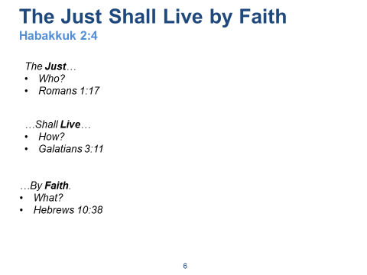

***The Righteousness of God is revealed from Faith to Faith…***

**2 Cor. 5:21** …”For He made Him who know no sin to be sin for us, that we might become the righteousness of God in Him.”

**What does God want of us?**

**1 Samuel 15:22** …”to **obey** is better than to sacrifice.” (**Matt 7:21**)

**Hosea 6:6** …”For I desire **mercy** and not sacrifice, and the **knowledge** of God more than burnt offerings.”

**Luke 1:27** …”You shall love the Lord your God with all your heart, with all your soul, with all your strength, and with all your mind, and ‘your neighbor as yourself.’”

What is the meaning of the phrase, “the just shall live by faith” (Hab 2:4), relative to the Patriarchal, the Mosaic, and the Christian eras?

* Within each era, the believer’s relationship to God is *based upon God’s promises* and not upon anything that the person (or nation) has done or could do.
* Within each era, sin is dealt with in accordance with God’s instruction, the believer simply obeys and accepts by faith that their sin is forgiven. Even the animal sacrifices of the Mosaic Law were based upon God’s **promise** that the sin condition would be relieved. Galations 3:19-29

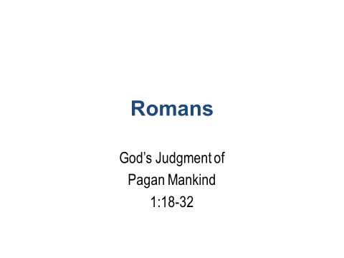

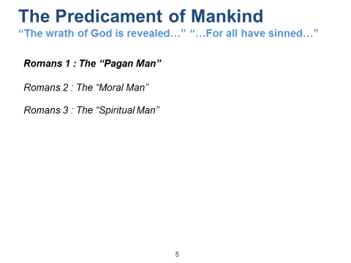

The first step in the revelation of the righteousness that God provides for people by faith is to set forth our need for it because we are under God’s judgment. We are born into a fallen race. The human race stands condemned before God and is helpless and hopeless apart from God’s grace.

**Read the summary statement of the first three chapters... 3:23-26**

**They Became Fools…**

* Man’s refusal to acknowledge and glorify God leads to a downward path:
  + First, worthless thinking;
  + Next, moral insensitivity; and
  + Then, religious stupidity as seen in idol-worship!
* And we become like the gods we worship (Ps 115:8, 135:15-18)

**The Pagan Man**

Naturalism – the belief that nature is all that there is.

The Empiricist looks to nature for truth; what he observes. God reveals Himself to men of this type via his creation.

Uniformity of Nature (e.g. the “Laws of Nature” being uniform across time & space) speak to the character of God. Such uniformity cannot be explained if the natural world were based upon mere randomness.

e.g. “Why is the universe discoverable? Understandable? Bound by natural laws? Comprising information?”

The universe reflects the unchanging character of God. We are made in his image and thus able to understand his creation.

**The Moral Man – The Philosopher**

The Moral Man looks inward for truth; what he reasons (i.e. Logic)

God has reveals Himself to this type of man within the concepts of right and wrong.

Morals reflect the character of God. We are made in His image and thus able to reason using logic of which he is the source.

**The Spiritual Man – The “Religious” Person**

One who recognizes the Sin Nature of Man. He seeks to “work” his way to a “right” relationship with his god.

The Religious Man looks to religion for truth; what he believes. A “heart” centric conditioned response.

God reveals Himself to men of this type via his special revelation of sin under the law (e.g. via the prototypical Jew) and redemption by grace within Christ.

Man says…

Humanism – man is the measure of all things.

Atheism – god doesn’t exist.

Pantheism – creation itself is the measure of all things.

God says…

***Hebrews 1:1*** *“God, who are various times and in various ways spoke in time past to the fathers by the prophets, has in these last days spoken to us by His Son, whom He has appointed heir of all things, through whom also He made the worlds; who being the brightness of His glory and the express image of His person, and upholding all things by the word of His power, when He had by Himself purged our sins, sat down at the right hand of the Majesty on high,…”*

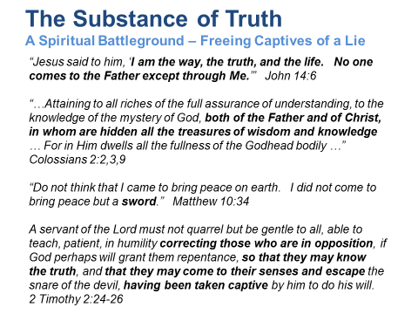

The Substance of Truth:

Biblically speaking, Truth is both relational and propositional. It is at one and the same time a Person – Jesus Christ, God in the Flesh – and also a set of verbally expressible, mentally comprehensible statements about that Person and the invisible God He reveals.

The Truth is consistent with reality; it matches the observable facts of the universe while simultaneously explaining realities we cannot see.

**Truth and Faith:**

*“Now* ***faith*** *is the substance of things hoped for, the* ***evidence*** *of things not seen.” Hebrews 11:1*

There is a tendency in our day to separate “reality” from “spirituality”. It’s part of the innate human propensity for compartmentalizing knowledge, belief, and behavior – in other words, for hypocrisy. Biblical Truth demands a total response. It elicits action as well as mental assent. If I believe that what I believe is really real, I will step out and act upon it. This is the meaning of the biblical word “faith”.

**Truth and Division:**

The light of Christ disperses the darkness of the devil’s lies. But in so doing, it splits human society and draws a line through the center of every human heart. In a fallen world – a world divided into warring camps – the Truth gains enemies simply by being true.

We must view those in opposition to truth as captives of a lie… *(Isaiah 44:14-20, v20)*

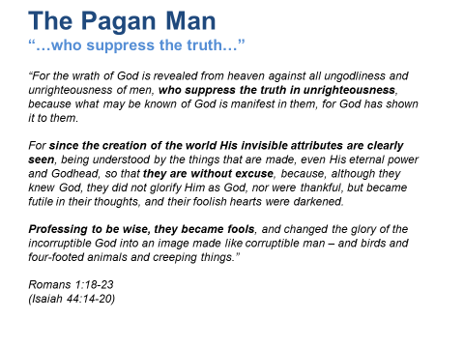

**Read 1:18-32 and then return to this section. Ask questions before next slide.**

**What are the basis stated for God’s judgment of the pagan world?**

* For Suppressing God’s Truth (v.18)
  + (King James correctly translates this as “Holding” Truth but by implication suppressing it.)
* For Ignoring God’s revelation (v.19-20)
* For Perverting God’s glory (v.21-23)

**How do men suppress the truth in unrighteousness?**

* Philosophies of Man (e.g. Humanism)
* Lies, False Teaching, and Artificial Authority
* Pride, Selfishness, and Hatred
* Claiming Presuppositions as “Facts”

**What are some secular presuppositions?**

* Naturalism – Nature is all that there is (e.g. It is now illegal to teach Biblical Creation in public schools).
* Empiricism – “Science” is the authority
* Relativism – There is no standard of Truth.
* Neutrality – All religions are equal.
* Bible is irrelevant to science, government, and business – Exclusion of Faith from public discourse.

**What are some Biblical presuppositions?**

* The Bible is true
* Moral Absolutes
* Laws of logic
* Laws of morality
* Uniformity and Induction

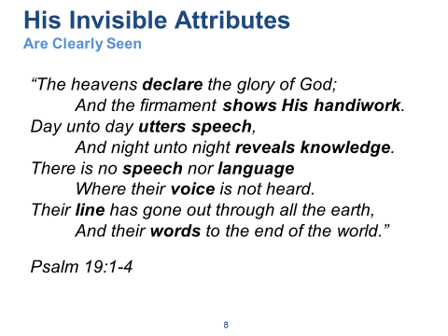

How can something that’s invisible testify to something that’s clearly seen?

* Design – It was designed that way from the beginning of creation!
  + Example: DNA
    - DNA – 3 out of 4 error correcting digital code (could not have arisen from randomness)
    - Everywhere in the universe is evidence of design

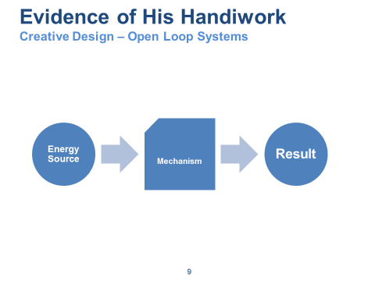

Example: Ceiling Fan

The “system” requires information and intelligence of first-level complexity.

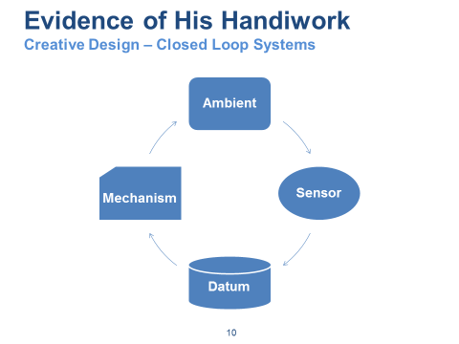

Example: Introduce a Thermostat

The system requires intelligence and creativity indicative of a second-level of complexity.

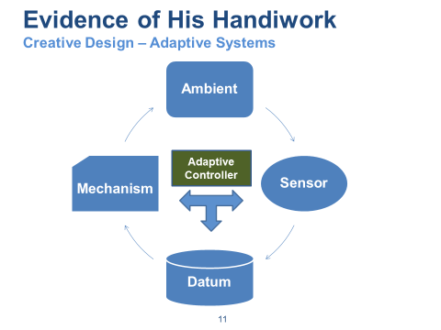

Example: Introduce a micro-controller that assimilates information and applies rules of logic.

The system now represents a high level of sophistication; only possible with significant creativity and design. Most systems of this class are designed by trained, professional engineers.

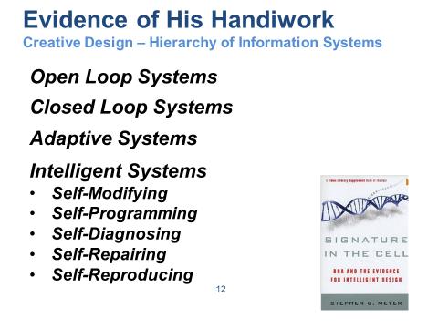

“Intelligent Systems” represent the pinnacle of known systems complexity. Man-made systems have not yet reached this level.

However, God’s handiwork is demonstrated by living systems (e.g. the living cell) that contain incomprehensible application of creative design.

Natural Information Systems complexity is a clue to God’s creative design. Each higher level of complexity requires adding information to the system.

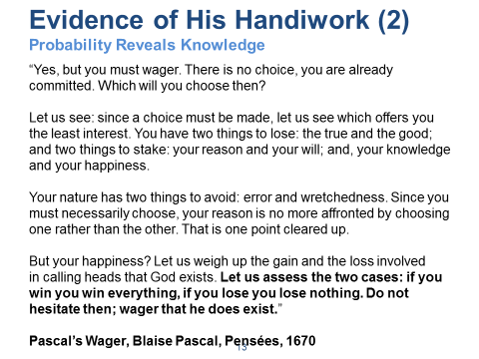

Another example of the inherent creative design evidenced within “information systems”.

From a mathematical, probabilistic, risk analysis perspective:

Type I Error: Rejecting a true hypothesis.

Type II Error: Accepting a false hypothesis.

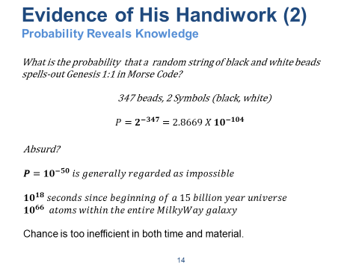

If you found a string of black-and-white beads and upon further inspection discovered it spelled out Genesis 1:1 in Morse Code. What is the probability that this sequence occurred through random chance?

347 beads; only 2 types: black and white; thus a “language” of 2 symbols.

P (random chance) = 2^-347 = 2.8669 x 10^-104

Note: (P < 10^-50 is defined as absurd!)

A basic concept herein is the concept of information conveyed within Language. In this example, Morse Code, utilizes a language symbol-set of 2 symbols. What about more sophisticated languages? (e.g. English alphabet of 26 symbols; ASCII code of 256 symbols; protein sequences using 20 symbols).

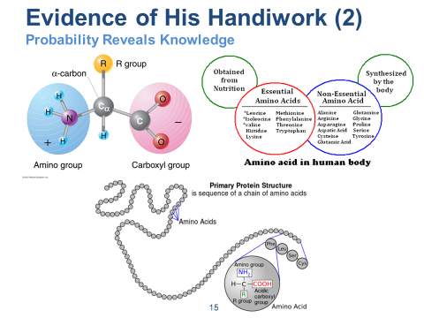

Molecules: Behave like groups of ball magnets; react with one another and with other catalysts (e.g. oxygen). Amino Acids are simply molecules that serve as the building blocks for all proteins (larger molecules) found in living cells.

Amino Acids: Consider the 20 essential amino acids that make-up all proteins in living cells; 10 our bodies manufacturer; 10 we obtain from our food

All amino acids found in proteins have this basic structure, differing only in the structure of the R-group or the side chain.

Right-handed versus Left-handed? (reacts to mutual destruction)

What happens in presence of Oxygen? (reacts to molecular destruction)

Language of Protein Sequencing:

* 20 Symbols; 20 Essential Amino Acids; a “Language”
* Arrange these in specific sequence to produce all proteins (i.e. to convey information)
* Arrangement itself is syntactic. Meaning (i.e. functional specificity) of the sequence is semantic. We are considering only syntactic probability. Semantic meaning is profoundly more indicative of Intelligent, Creative Design.
* Probability calculations consider only the syntactic nature of the sequence. Generally, only a small number (e.g. one in many cases) of permutations in all possible permutations determines a “correct” sequence semantically.

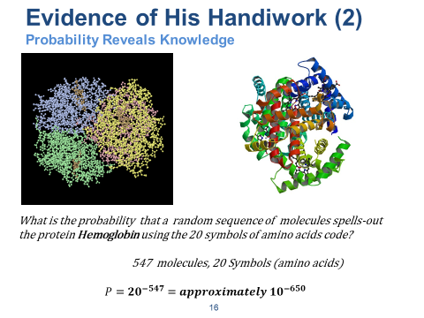

Consider the Hemoglobin molecule (i.e. protein sequence)…

Chemical Composition:

Hemoglobin; about 96% of red blood cell (dry weight) is the protein molecule Hemoglobin; binds and transports Oxygen and other gases to/from cells.

Formula for linear arrangements: N=n!/(p! x q! x r! …)

There are approximately 10^650 permutations possible; nearly only one of them is hemoglobin (i.e. a very small change in the “correct” syntactic sequence? = Hemoglobin Opathy). Only very small variations are permissible relative to functional specificity.

Far beyond “chance”.

The Elements of Language:

* Syntactic
* Symantec

Is this an example of a random accident (chance)? Or coordinated planning (design)?

How does this example (i.e. Hemoglobin) compare to more complex protein sequence structures (e.g. DNA)?

Where did the functional specificity (i.e. semantic meaning within the context of application) come from? How? How can we know?

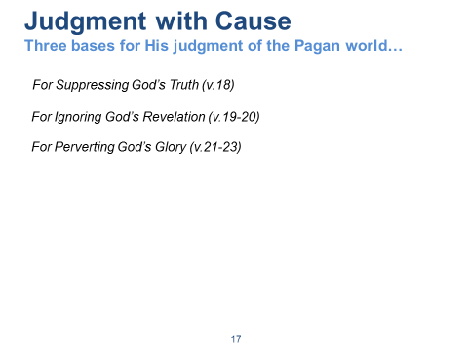

**Psalm 19; Romans 1**

* For Suppressing God’s Truth (v.18)
* For Ignoring God’s revelation (v.19-20)
* For Perverting God’s glory (v.21-23)

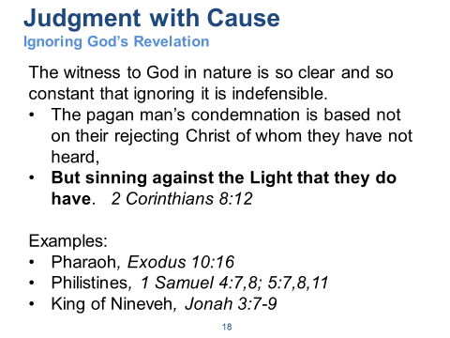

**How do we reach the pagan man with the Gospel?**

1. Argument from Design
   1. All Designs imply a Designer
   2. There is great design in the universe
   3. Therefore, there must be a Great designer of the Universe
2. Argument from Creation
   1. The Universe had a beginning
   2. Anything that has a beginning must have been caused by something else
   3. Therefore, the universe was caused by something else, and this cause was God

Five key questions to focus conversation with non-believers:

1. What do you mean by __________?
2. How do you know?
3. What difference does that make?
4. What if you are wrong?
5. What would you accept as evidence?

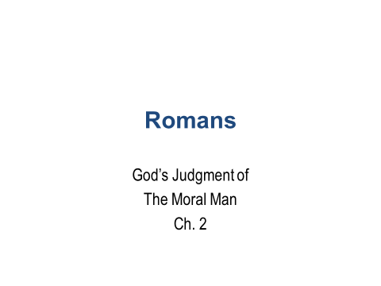

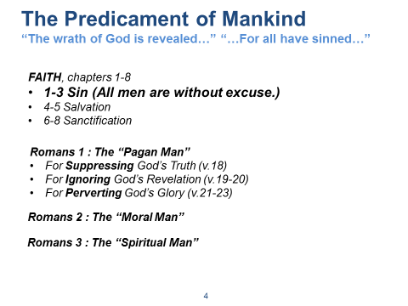

**REVIEW**

**The Pagan Man - They Became Fools…**

Man’s refusal to acknowledge and glorify God leads to a downward path:

* First, worthless thinking;
* Next, moral insensitivity; and
* Then, religious stupidity as seen in idol-worship!

The witness to God in nature is so clear and so constant that ignoring it is indefensible.

* The pagan man’s condemnation is based not on their rejecting Christ of whom they have not heard,
* **But sinning against the Light that they do have**.  *2 Corinthians 8:12*

*Case Study: Sodom*

* *Ezekiel 16:48-50*
* *For what cause did God “take them away”?*
* *Was this “fair” of God?*

The first step in the revelation of the righteousness that God provides for people by faith is to set forth our **need** for it because we are under God’s judgment. We are born into a fallen race. The human race stands condemned before God and is helpless and hopeless apart from God’s grace.

**What Law is at play in this judgment scenario?**

* The Law of Sin and Death (Romans 8:2)

**Is this a real law?**

* Compare to other “natural laws” like gravity, cause and effect, entropy, others.

**Review our “court-room” scenario… The 3 men in the dock; the Judge; the Jury… What type of glasses are we all wearing?**

**Is pagan mankind guilty?**

* **How do you know?**
* **Do you now judge the Pagan man guilty?**
* **Read Romans 2:1-3 (PAUSE)**
* **What about Matthew 7:1-2 ???**
* **What about I Cor. 2:13-16 ???**
* **What is the common thread? A common measuring stick that we all possess and recognize?**
* **Aren’t we (i.e. the jurist) now also defendants?**

**Read I Corinthians 2:13-16**

* **How can we “know” anything? (“But we have the mind of Christ.”) How is this possible? John 18:37**
* **What is meant by v15? What is meant by “rightly judged”?**
* **Is this passage a clue as to the meaning of Jesus’ statement, “Everyone who is of the Truth hears My voice.” …?**
* **Is this a clue as to the power of the glasses we are given to wear as jurors within the Romans 1-3 court-room?**
* **What is the correlation within I Cor 3:9-15 …?**

**Review how the court-room changes as we enter chapter 2.**

**Let us not confuse Romans 2 with Revelation 20… at Judgment Day (Rev 20), there will be no reasoning or preaching; only condemnation; based upon the Principles of God’s Judgment.**

**The Agent of divine judgment is Jesus Christ. John 5:22, 27; Acts 17:29-31**

**Now that Jesus is the divine judge within our court-room…**

* **What does this say about God’s “fairness”?**

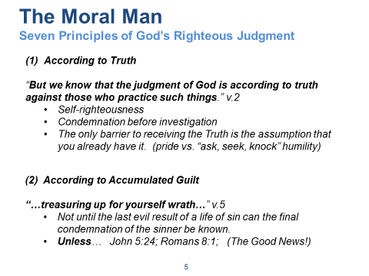

**What is the greatest thought that ever entered the mind of Man?**

**“My responsibility to my Maker!” Daniel Webster**

**How does God deal with Man individually? Ezekiel 18…? Mankind Corporately?**

**According to Truth…**

* **In this court-room, we are privileged to be wear (as jurists) the glasses of God’s Truth… to see the evidence with the Mind of Christ (1 Cor 2:15).**
* **Emphatically! We MUST always wear these when doing Kingdom work (in humility, planting, watering, answering, with compassion).**

**Seven principles dealing with how God will decide and respond to mankind.**

1. According to Truth

* Do you think that you will escape judgment – You? Self righteousness is a death sentence that we all share in. (Ezekiel 16:48-50)
* The principle that keeps us in ignorance is condemnation (coming to a conclusion) before investigation.
* v4, Not only do we feel ourselves innocent, but the riches of God should be leading us to repentance.
* Note God’s progressive degrees – goodness, forbearance, and longsuffering – in responding to our ingratitude.

(2) According to Accumulated Guilt

* The First Law of Holes… stop digging.
* Ezekiel 16:49-50 – Example Sodom and Gomorrah – pride; more than homosexuality
* Luke 17:28-30
* Prosperity always feeds pride; it’s easy to be humble when you are poor.

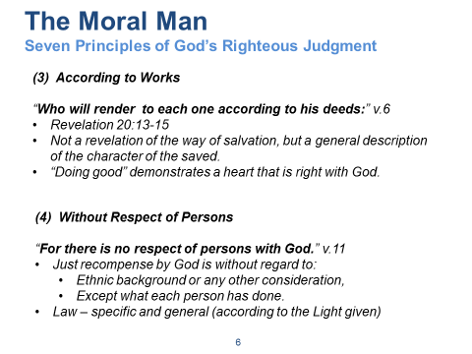

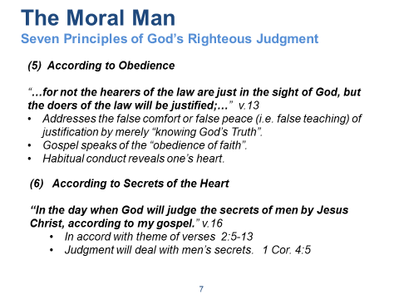

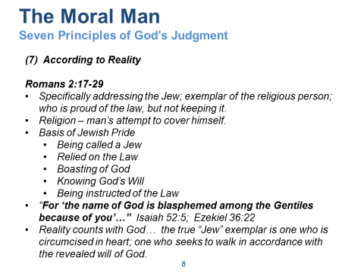

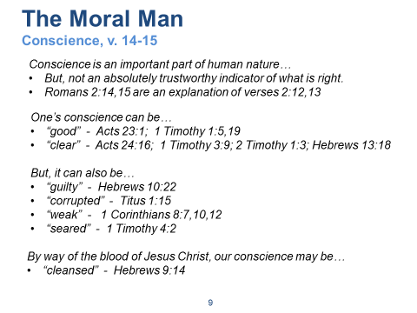

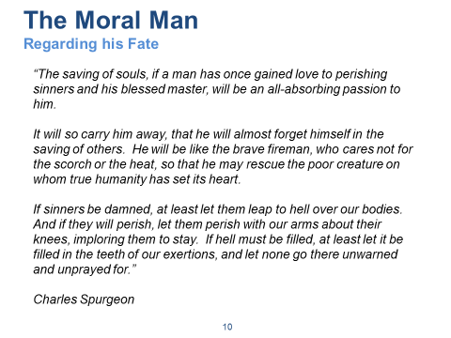

**Let us not confuse Romans 2 with Revelation 20… at Judgment Day, there will be no reasoning or preaching; only condemnation; based upon the Principles of God’s Judgment.**

**The Agent of divine judgment is Jesus Christ. John 5:22, 27; Acts 17:31; Hebrews 9:27**

**How to evangelize to The Moral Man?**

**How do we think about this predicament in order to help mankind?**

* Situation
* Problems
* **Implications**
* **Needs**
* Within the context of Truth…
  + Origins
  + Meaning
  + Morality
  + Destiny

***The Righteousness of God Revealed***

* God created man “in His own image.”
  + Since we are persons, so is God
  + Since we have personal feelings, so has God
  + **Implications?**
    - If God be God, He must be the judge of all.
    - We must meet God as He is, not as we wish Him to be.
    - We need to really understand how He sees things… not as how we imagine Him to be.
    - We don’t want to hug our own delusions to our own damnation.

**Needs?**

* Truth
* Compassion Now! (Luke 16, Lazarus, too late to help the lost)
* How would you describe your current attitude about the fate of the lost?
  + Unconcerned
  + Concerned
  + Alarmed
  + Horrified

**What about you and I…?**

* Psalm 139
* Jeremiah 1:5-10
  + What was Jeremiah’s response (v6)?
  + What was the real underlying reason (v8)?
  + What was Jeremiah given (v9-10)? Do we have this same knowledge? (Jeremiah 31:31; Hebrews 8:10)
* Paul
  + I Corinthians 2:1-5

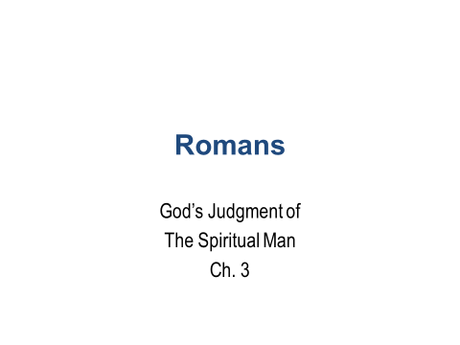

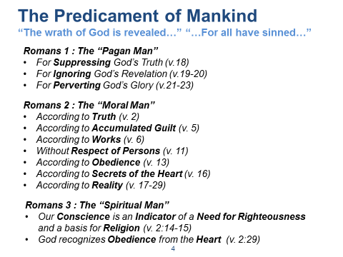

**The Pagan Man - They Became Fools…**

Man’s refusal to acknowledge and glorify God leads to a downward path:

* First, worthless thinking;
* Next, moral insensitivity; and
* Then, religious stupidity as seen in idol-worship!

The witness to God in nature is so clear and so constant that ignoring it is indefensible.

* **The pagan man’s condemnation is based not on their rejecting Christ of whom they have not heard,**
* **But sinning against the Light that they do have**.  *2 Corinthians 8:12*

NOTE: God’s prior judgments of mankind (i.e. condemnations) reveal that He judged them apart from the Law and according to the eternal principles of His Revealed Truth (e.g. Sodom and Gomorrah, Noah’s Flood).

**The Moral Man – Seven Principles of God’s Righteous Judgment**

**\*\*\*\* The First Law of Holes… stop digging**! ****

**Let us not confuse Romans 2 with Revelation 20… at Judgment Day, there will be no reasoning nor preaching; only condemnation; based upon the Principles of God’s Judgment.**

**The Agent of divine judgment is Jesus Christ. John 5:22, 27; Acts 17:31**

**Judgment**

* The Same Measuring Stick (we all know and use the same stick):
  + *Romans 2:1-2*
  + *Matthew 7:1-2 (passing judgment should give us pause…)*
* *Does not imply “do not pass judgment – i.e. discernment”*
  + *1 Corinthians 2:14-16 – the spiritual man makes judgment about all things*
* Different judgments
  + Examples of prior Judgments (with condemnation) by God: Ezekiel 16:48-50 (Sodom and Gomorrah – pride **and** sexual perversion; see also Luke 17:28-30)
  + At the end: *Revelation 20:13-15 (“…treasuring up for yourself wrath…” Romans 2:5)*
  + *Even the Christian: 1 Cor. 3:11-15 (but not condemned…! John 5:24; Romans 8:1)*

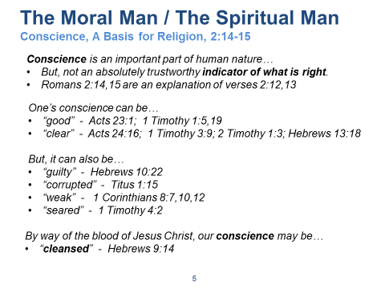

**What is the greatest thought that ever entered the mind of Man?**

**“My responsibility to my Maker!” Daniel Webster**

**Men recognize a void in themselves…, and sometimes seek to fill that void with religion.**

**(basically a selfish drive) (we’ll see that even in man’s best effort, his corporate attempt; religion; that man is not good…)**

*The Righteousness of God Revealed*

* God created man “in His own image.”
  + Since we are persons, so is God
  + Since we have personal feelings, so has God
  + We all recognize the need for universal judgment! (we’ve all just judged pagan man in our reading of chapter 1…!)
  + **Implications?**
    - If God be God, He must be the judge of all. (We’ve all agreed, v. 2:1-2, that universal judgment is warranted.)
    - We must meet God as He is, not as we wish Him to be.
    - We need to really understand how He sees things… not as how we imagine Him to be.
    - **We don’t want to hug our own delusions to our own damnation.**

**Needs Analysis…? A basis for Religion… (the implications of our condition requires a solution)**

S.P.I.N.

Situation – is self-evident

Problems – are experienced universally

Implications – are recognized by all

Needs Analysis – solutions are sought by all and translated by intent.

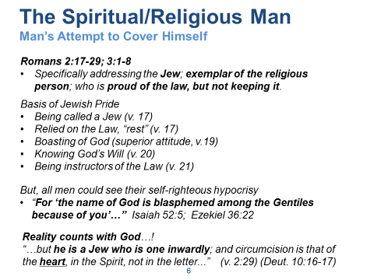

**Read 2:17 thru 3:8**

Were the Jewish people “better” (e.g. culturally) than others?

* Arguably “yes”… compare OT laws about health and living systems vs. others (e.g. hygiene, food restrictions, “keepers of God’s Laws”)
* Jews had set aside the “hope of the Messiah” as the Light (even unto Gentiles) and assumed themselves to be the Light.
* i.e. arrogant conceit
* They had the “form of the Law”, an adaptation of the “original Law”
* Paul uses the very Law the Jew trusts in to “root him out”….

Note: Historically, the Church had begun in the Jewish community; most of the early Christians (in the years after pentecost) were Jews. But, here we are 30-40 years since then and the Church had largely become a Gentile phenomenon. Paul (as he traveled and preached in the synagogues) undoubtedly faced a hostile, taunting, perhaps demeaning audience of Jews. Hence, his focus on a Jewish centered argument from that perspective.

Sub-argument (circumcision is of the heart – **Deut 10:16**):

* The Jew (*being* circumcised under the law) would not receive covering under the law *without* obedience…
* And, the Gentile (*not* *being* circumcised under the law) could receive covering under the law *with* obedience (argument from v. 2:13)…
* Therefore, the Jew would argue (tauntingly)… **Romans 3:1-8**
  + What advantage is there in being a Jew…? If we are made right with God by His Grace alone, then…
  + Isn’t it the case then that our unrighteousness further increase God’s glory…?
  + ***Discuss Job 38:1-3; Job 40:2; Job 40:8***
  + Discuss Psalm 51:4
  + (Similar argument today – is baptism then really necessary? )

**The Starting Place of Faith (God’s Truth is not determined by our assessment of it…):**

* *3:3 “Let God be true and every man a liar…”* 
  + *We all know about truth because we all comprehend what a lie is… (the negative reveals the positive)*
* *3:4 Men are judging God…! (Psalm 51:4) Man says… “God doesn’t have the right to judge me..! I am as he has made me…” Discuss Job 40:8*
* *3:5-9 Paul assents to their argument and then demonstrates how the argument can’t be true because it contradicts God’s own nature… (How can a perfectly just God not apply justice?)*
* Sin is born of motivation….! Who is really good?

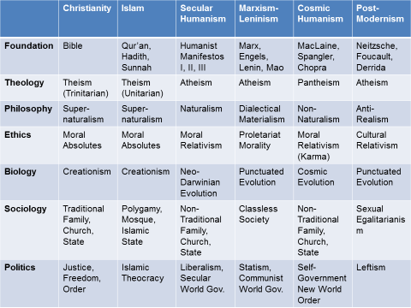

*They (i.e. world religions) can’t all be true!*

**Comparing competing world-views**

Reference: “Understanding the Times, The Collision of Today’s Competing Worldviews”, David A. Noebel

**The Religious Man looks to the practice of religion for righteousness. He develops exhaustive belief systems. He recognizes the Sin Nature of Man and seeks to “work” his way to a “right” relationship with his god.**

God reveals Himself to mankind via his special revelation of sin under the Law (i.e. via the prototypical Jew) and points mankind instead to redemption by grace within Christ.

*Man says…*

Humanism – man is the measure of all things.

Atheism – god doesn’t exist.

Pantheism – creation itself is the measure of all things.

*God says…*

*Hebrews 1:1 “God, who are various times and in various ways spoke in time past to the fathers by the prophets, has in these last days spoken to us by His Son, whom He has appointed heir of all things, through whom also He made the worlds; who being the brightness of His glory and the express image of His person, and upholding all things by the word of His power, when He had by Himself purged our sins, sat down at the right hand of the Majesty on high,…”*

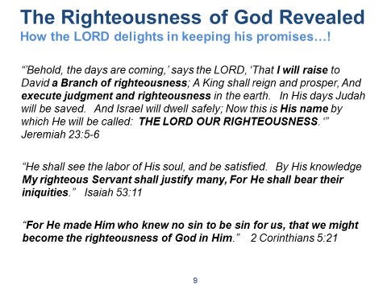

**FIRST, Read Galatians 3:19-29**

**The Promises of GOD are the currency upon which man-kind’s ultimate hope and destiny rest. Discuss how GOD made promises to Abraham, Moses and the Israelites, and to us (Jer 31:31).**

**What should our response be?**

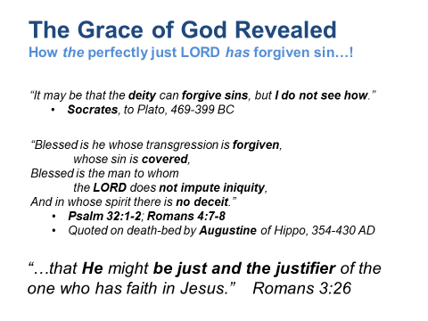

**FIRST - Read Romans 3:21-26**

* How can a perfectly **just** God forgive sins?
* How can **sinful** man find favor with a **righteous** God?

**THE ANALOGY:**

* God (the Son) presides as the Judge of mankind (pagan, moral, and spiritual men). John 5:22
* The Son steps down from the Judgment seat and assumes the seat of the plaintiff (mankind). Isaiah 53:11
* The Son himself assumes the just penalty of sin for all of sinful mankind.
* The Father is satisfied with the just payment for sin.
* The Father demonstrates mercy by extending the righteousness of one man to cover many. 2 Cor. 5:21

**God demonstrates His perfect justice at the same time that he demonstrates His perfect mercy… in the act of delivering justice, he also justifies.**

Eph. 2:8 “For by grace you have been saved through faith, and that not of yourselves; it is the gift of God, not of works, lest anyone should boast.

**Hallelujah! What a Savior**

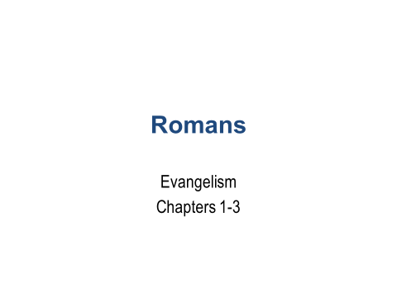

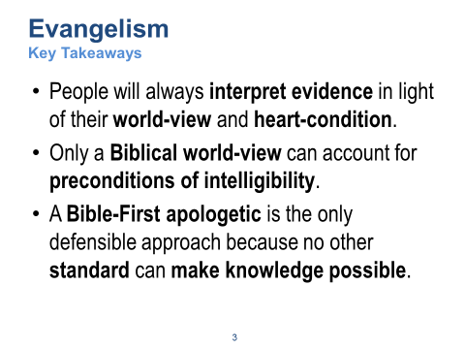

1. We all see the same facts or evidences, but we also interpret these based upon fundamental presuppositions. Evidence by itself will not resolve a world-view conflict.
2. Where do Laws of Logic (reasoning) come from? How about Laws of Nature like gravity? Why should we expect to find uniformity of these laws within the universe?
3. How can we know that anything is good, bad, right, or wrong? Even the atheist must borrow these ideas from the biblical God. If the Bible were not true, it would be impossible to prove anything.

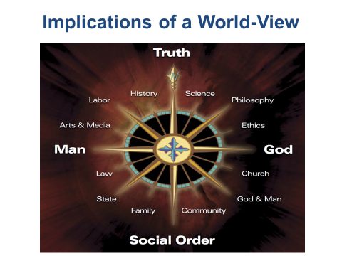

Components of a World View:

Origin

Meaning

Morality

Destiny

World-View: Assertions and Assumptions; Lens through which we view and evaluate all things.

Must be:

Logically Consistent: Reasonable

Empirically Adequate: Able to verify

Experientially Relevant: Applicable in Life

World-View Tests:

Correspondence: To particular questions, your answers must correspond to reality.

Coherence: All of your answers must, in total implication, summarize coherently.

World-Views may be systemically flawed. No need to examine every detail.

(Ex: Muslims deny Christ's death, though historically verifiable.)



**Comparing competing world-views**

Reference: “Understanding the Times, The Collision of Today’s Competing Worldviews”, David A. Noebel

**The Religious Man looks to the practice of religion for righteousness. He develops exhaustive belief systems. He recognizes the Sin Nature of Man and seeks to “work” his way to a “right” relationship with his god.**

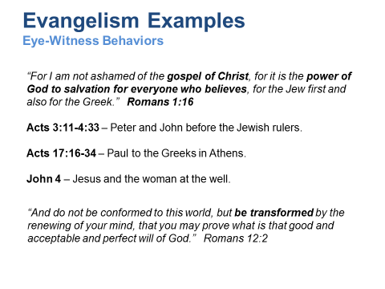

**People were Transformed by Jesus Christ**

* The first 30 years (33-64): the Jewish community was transformed. Over the next 300 years, the “known world” was transformed. *Acts: 17:6*
* Some eyewitnesses were **not** transformed (Jesus laments the apathy of witnesses of miracles during His ministry): *Matthew 11:20-24*

**Jesus Transformed His Disciples**

* How did the disciples behave prior to the crucifixion? During? After? What changed?
  + Jesus told them in advance what would occur… *Luke 9:22*
  + They did not understand nor believe it… *Luke 24:11*
  + What did they see and experience…? *John 20:19-20; John 20:28; Luke 24:37-43*
  + What did they learn…?
    - The appearances of Christ’s physically resurrected body not only transformed the disciples from fear and doubt, but it also enabled them to understand what Jesus had told them before His crucifixion. He said, *“I am the resurrection and the life. He who believes in me will live, even though he dies; and whoever lives and believes in me will never die…” John 6:40*
    - They finally understood that he would someday also raise them from the dead and that they, as believers in Him and His resurrection, would live forever.
    - They were transformed and motivated to proclaim the message of the Truth. *John 14:6, Acts 4:12*
    - *“We cannot help speaking about what we have seen and heard…” Acts 4:20*

**More People were Transformed**

* Stephen, the first Martyr, Acts 6-7
* James, the brother of Jesus, (Skeptic before, Mark 3:21); (believer and Martyr after, Acts 1:14, Acts 12:2)
* Saul (Paul), (Skeptic, Acts 8:1); (believer and Martyr, 2 Timothy 4:16)
* An army of Martyrs, Acts 8:4
  + Did Christ warn them? (Matthew 10:22; Matthew 10:28)
  + Their report was strengthened by works of the Holy Spirit… (Acts 2:41; Acts 9:35; Acts 9:42)
  + Theirs was not a superficial Faith (they were moved to obey Christ’s teaching and to reject pagan lifestyles; John 14:15, 1 Peter 4:3)

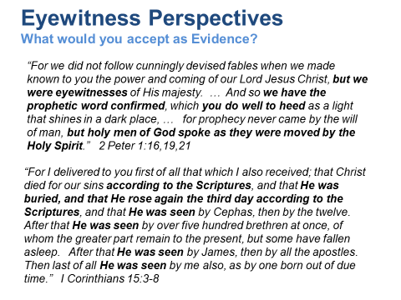

The Apostles are eye witnesses, but they appeal to prophecy (i.e. Scripture) for much of their argument. Something that their Jewish audience was well-versed in.

2 Peter 1:16-21 🡪 “We were eyewitnesses alright; but you have something better; i.e. ‘prophetic word confirmed’.” (paraphrase)

Key Question: “What would you accept as evidence?”

---------

Five key questions to focus conversation with non-believers:

1. What do you mean by __________?
2. How do you know?
3. What difference does that make?
4. What if you are wrong?
5. What would you accept as evidence?

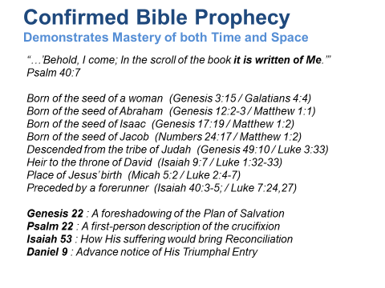

Over 300 documented prophetic scriptures that Christ fulfills. See Josh McDowell’s “New Evidence that Demands a Verdict”.

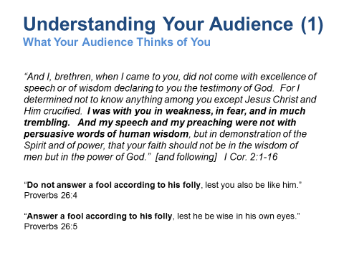

Paul adjusted his behavior in order to focus his audience upon the message and not upon himself.

Understand what your audience (typically secular humanists or post-modernists today) think of you:

Examples:

1. Your message is not sophisticated.
2. Your Truth is not reasonable.
3. Your argument is not empirical.
4. You are not impressive (i.e. elite, non-credentialed).

------------------------------------------------------------------------

We learn that we are not to answer the unbeliever according to his folly – according to his fallacious presuppositions. We are not to accept his standards for the debate, because they are nonsense.

**The “Don’t Answer --- Answer” strategy**

Jesus used this technique… Matthew 12:24-29 and at other times. The Pharisees asserted that Jesus was only able to cast out demons because He Himself was using the power of Satan (“Beelzebul”) – not God. Jesus responded using the “don’t answer, answer” strategy. He did not accept their foolish standard (“don’t answer”), but then He showed how silly their position was by showing what would hypothetically happen if it were true (“answer”).

------------------------------------------------------------------------

Five key questions to focus conversation with non-believers:

1. What do you mean by __________?
2. How do you know?
3. What difference does that make?
4. What if you are wrong?
5. What would you accept as evidence?

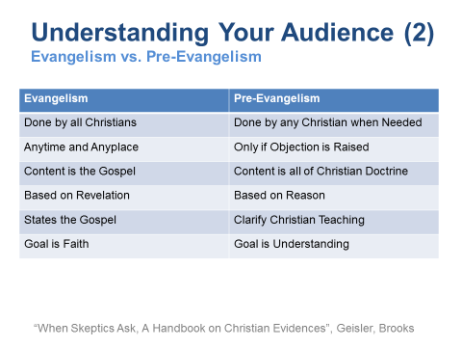

**Natural Man : Address the Intellect**

**Moral Man : Address the Conscience**

**Spiritual Man : Address the Heart**

**Reasoning from History, Creation, Morality, and Sin**

“If someone does not believe that God exists and that He can perform miracles, then it makes no sense to him to say that God raised Jesus from the dead (a big miracle!).”

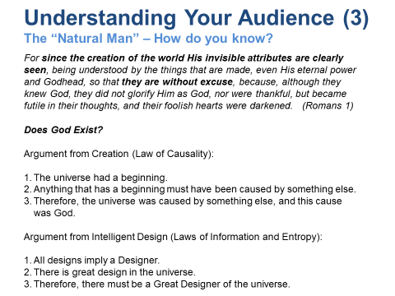

Naturalism – the belief that nature is all that there is.

**Creation proves that there is a Creator.**

The Empiricist looks to nature for truth; what he observes. God reveals Himself to men of this type via his creation.

Uniformity of Nature (e.g. the “Laws of Nature” being uniform across time & space) speak to the character of God. Such uniformity cannot be explained if the natural world were based upon mere randomness.

e.g. “Why is the universe discoverable? Understandable? Bound by natural laws? Comprising information?”

The universe reflects the unchanging character of God. We are made in his image and thus able to understand his creation.

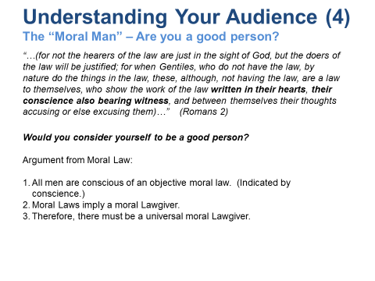

The Moral Man looks inward for truth; what he reasons (i.e. Logic, Conscience).

**The “Will of God” observable in nature. (The Law of Moses may be considered a revealed specification of this natural law.)**

*Moral laws don’t describe what is; they prescribe what ought to be. They are not simply a description of the way men behave, and are not known by observing what men do. If they were, our idea of morality would surely be different. Instead, they tell us what men ought to do, whether they are doing it or not. Thus, any moral “ought” comes from beyond the natural universe. You can’t explain it by anything that happens in the universe. It transcends the natural order and requires a transcendent cause.* (“When Skeptics Ask”, Norman L. Geisler)

God has reveals Himself to this type of man within the concepts of right and wrong (via the conscience).

Morals reflect the character of God. We are made in His image and thus able to reason using logic of which he is the source.

**Practical Example**

Made evident using questions from the Law.

Questions:

1. Would you consider yourself to be a good person?
2. Do you think that you have kept the Ten Commandments?
   1. Have you ever lied?
   2. Have you ever stolen something?
   3. Have you committed adultery? Perhaps even in your thoughts?
   4. Have you disobeyed and dishonored your parents?
3. If God were to judge you by the Ten Commandments, do you think you would be innocent or guilty?
4. Are you aware of the Law of Sin and Death? Do you think that applies to you too?
5. Do you think that you would escape the consequences of this law?

Follow-on Questions:

1. Does that concern you?
2. Did you know that Jesus overcame the Law of Sin and Death for all humanity?
3. Do you want to know more about how to become “right” with God?

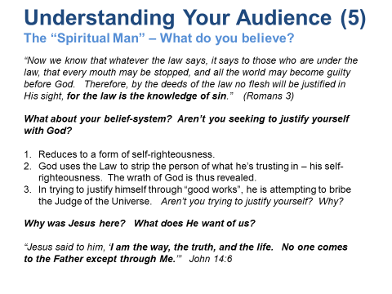

The Religious Man looks to religion for truth; what he believes. He recognizes the Sin Nature of Man and seeks to “work” his way to a “right” relationship with his god.

God reveals Himself to men of this type via his special revelation of sin under the law (e.g. via the prototypical Jew) and redemption by grace within Christ.

Man says…

Humanism – man is the measure of all things.

Atheism – god doesn’t exist.

Pantheism – creation itself is the measure of all things.

God says…

*Hebrews 1:1 “God, who are various times and in various ways spoke in time past to the fathers by the prophets, has in these last days spoken to us by His Son, whom He has appointed heir of all things, through whom also He made the worlds; who being the brightness of His glory and the express image of His person, and upholding all things by the word of His power, when He had by Himself purged our sins, sat down at the right hand of the Majesty on high,…”*

**Five key questions to focus conversation with non-believers:**

1. What do you mean by __________?
2. How do you know?
3. What difference does that make?
4. What if you are wrong?
5. What would you accept as evidence?

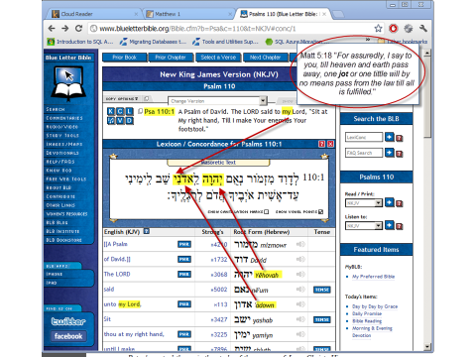

**An example of how Jesus responded to an errant religious system of beliefs…**

An example of how Jesus responded to an errant religious system of beliefs…

We should be reminded of Jesus’ words as quoted in Matthew 5:18… “…one jot or one tittle will by no means pass from the law till all is fulfilled.”

The jot is the Hebrew character illustrated here that looks similar to an apostrophe. It modifies the preceding word to form a ‘possessive’ grammar (e.g. Lord becomes “my Lord”).

Jesus used this passage (Psalm 110:1) to confuse the Pharisees who could not reconcile the concept of “Son of God” versus “Son of David” (whose throne they regard as that upon which the Messiah must be coming to fulfill).

“The Son of David” versus “The Son of GOD” Matthew 22:34-46 (41-46) (also: Mark 12; Luke 20; Acts 2)

The Jewish religious leaders were incorrectly focused on the Davidic Kingdom aspect of prophetic scripture. They expected (perhaps demanded) God to provide a Messiah that would rule the Earth from Jerusalem. Jesus uses a Messianic prophecy written by David himself to confound their reasoning. What did David mean when he prophesied concerning the Christ?

The small mark that appears at the end of the upper red arrow is a “jot”. It looks somewhat like an apostrophe. This jot is appended to the word “Lord” and creates a “possessive” context around that word (i.e. “my Lord”). Hence, the rendering “Jehovah said to my Adonai…” (in effect, the Christ would sit at the throne of God Himself, not in Jerusalem; certainly not an earthly throne.)

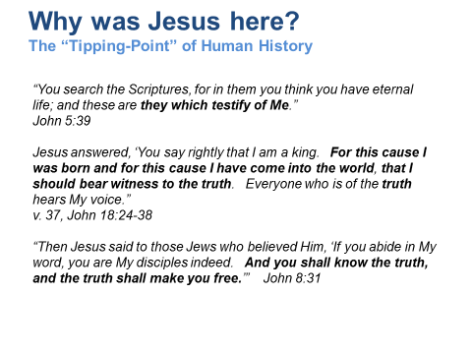

And, why at that time and place?

There are several possible answers to that question, but let’s allow the Bible to speak… it is the scriptures that testify of Jesus.

v.39… “What is truth?” Pilate doesn’t seem to have grasped the importance of his ironic question. Without the plumb line of Truth, we can know neither life, goodness, righteousness, nor justice. We can’t even know ourselves. **This is why Jesus, the King of all creation, came into the world to serve and bear witness to the Truth.**

What does it mean to live in a world without Truth?

*Isaiah 59:14, 15 “Justice is turned back, and righteousness stands afar off; for* ***truth*** *is fallen in the street, and equity cannot enter. So truth fails, and he who departs from evil makes himself a prey.”*

*“For the wrath of God is revealed from heaven against all ungodliness and unrighteousness of men, who suppress the* ***truth*** *in unrighteousness…”*

*Romans 1:18*

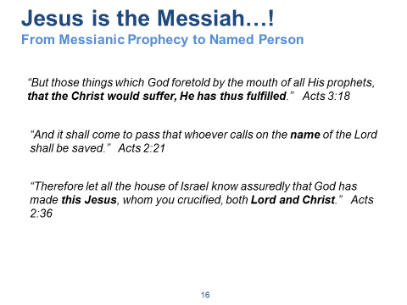

**This is the key Pentecostal proclamation: Jesus is Lord and Christ!**

(Isa 53; Isa 61)

Acts 3 – Peter identifies Jesus with the core Messianic prophecies that all Jews would recognize.

* Acts 3:18, Peter relies upon prophecy to make his case before the Jews. [Read thru 3:26]
  + What prophecies does Peter mention in this short passage? Did he expect the audience to recognize these? Why would they be expected to recognize these OT passages?
* What about v. 3:19-21…? Is Peter herein also prophesying? Is this yet to be fulfilled?
* What prophecy indicated that the Christ would suffer…? (Is. 53, others?)
  + Was this the common or popular understanding of the Messiah?
* What prophecy indicated that the Christ would reign…? (Daniel 7, others?)

Acts 2 – Although Peter’s speaks to the fulfillment of prophecy concerning the Holy Spirit (v 17-21), Jesus is the primary subject of his sermon.

* V. 22-36
  + Jesus, not the Holy Spirit, is the primary subject. Peter uses text from Joel to explain what the crowd is now witnessing.
* V. 21-22
  + Naming the specific person who is the Messiah, Jesus of Nazareth. The NAME is significant – “…whoever calls on the name of the LORD…”
  + Approved (demonstrated) of God as a perfect man.
  + Examples of other instances wherein the **name** of Jesus is made to be specific in context of Messianic prophecy:
    - John 1:45 – Philip to Nathanael… “We have found Him of whom Moses … wrote – Jesus of Nazareth, the son of Joseph.”
    - Mark 1:24 – The demon possessed man
    - Math 21:11 – The Triumphal Entry
    - John 19:19 – Pilate affixed name to cross
    - Mark 16:6 – Angel at resurrection tomb
    - Luke 24:19 – To men on Emmaus road
    - Acts 2:21-22 – Peter at Pentecost
* V. 23
  + Referred to the death of this specific person.
* V. 24
  + This specific person is raised from the dead.
* V. 33
  + This specific person is exalted.
  + He received from the Father the ancient **promise** of the Holy Spirit.
    - Joel 2:28; Luke 24:49; Acts 1:4
  + He specifically has poured forth the Spirit. Jesus Christ was promised the Holy Spirit, from the Father (John 16; Joel 2:28). So Peter is saying that what the people are seeing is Jesus Christ receiving the promise of the Father being fulfilled; i.e., The Holy Spirit.
* V. 34-36
  + Peter quotes Psalm 110:1 to emphasize that David himself was speaking of the Messiah (not David, who has not ascended into heaven) and identifying such as the Son of God
    - “Jehovah said to Adonai…” This is the quote that Jesus used to totally confuse the Pharisees in Matthew 22:41-45.
    - The grammar of the possessive “my Lord” hangs on a single jot!” Matt 5:18
    - How is this passage use in the gospels…?
      * Matt 22:44; Mark 12:36; Luke 20:42;
    - Note “Until” and not “While”… Rev 6-19

This is the climax of Peter’s sermon. He quotes from three different portions of Scripture, and builds this sermon on the person of Jesus Christ.

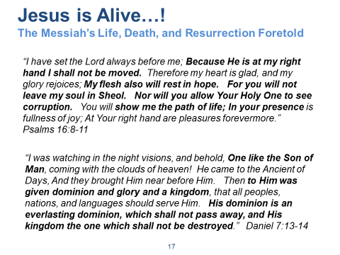

**Jesus’ identity and our Faith hang on fulfilled prophecy and the fact of the Resurrection. Phil 2:9-11**

Peter references Psalm 16:8-11 to illustrate that Jesus resurrection was further proof that He is the Messiah. For death cannot keep a hold on Him. He notes that this passage cannot refer to David, because David died and his remains “are with us today”.

The resurrection of the Lord is a basic doctrine in Acts:

* 2:32
* 3:15, 26
* 4:10
* 5:30
* 10:40
* 13:30, 33-34, 37
* 17:31
* 26:23

*It’s interesting to note how the Jewish scholars were confused by the Messianic prophecies. They tended to favor those that illustrated the Messiah at the head of a political kingdom.*

What OT passages present the Messiah as a suffering servant? As one experiencing death?

Psalms 22

Isaiah 53

Isaiah 61

Genesis 22 (type or foreshadowing)

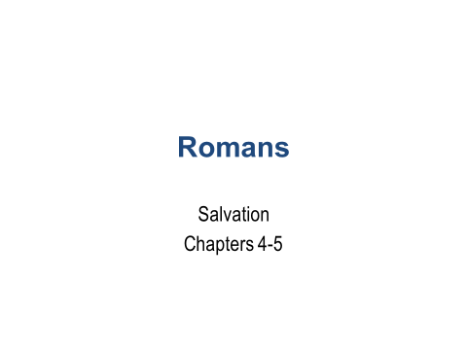

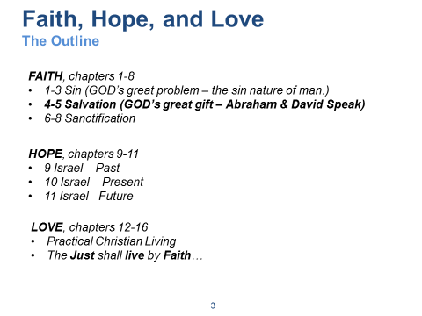

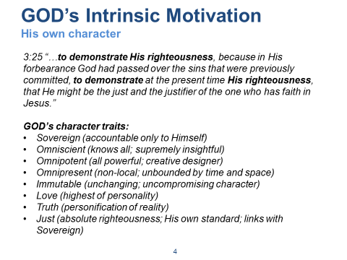

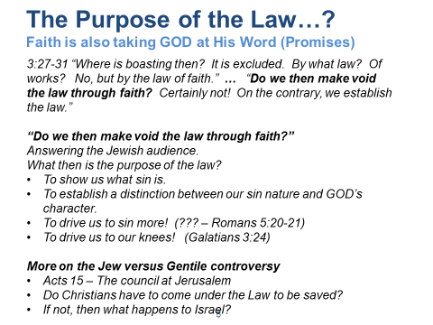

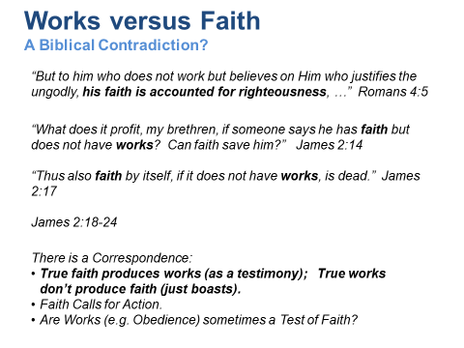

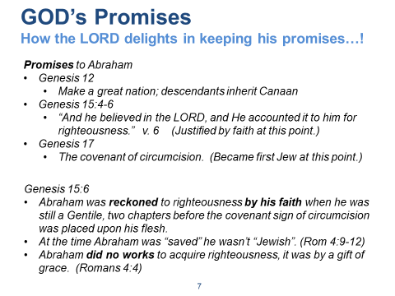

Abraham: The Father of the Jews (fleshly, v1, versus spiritual, v16)

FIRST, Read Romans 4:1-12

The Jews were proud of Abraham and themselves. The Rabbis had taught that Abraham had a surplus of merit from his works that was available to his descendants. Paul built on that idea and agreed that, assuming that Abraham was justified by works, he had something to boast about (cf. boasting or bragging in Rom 2:17, 23; 3:27). But, Paul insisted, his boasting could only be before other people, not before God.

**The Promises of GOD are the currency upon which man-kind’s ultimate hope and destiny rest. Discuss how GOD made promises to Abraham, Moses and the Israelites, and to us (Jer 31:31).**

**Read Galatians 3:19-29**

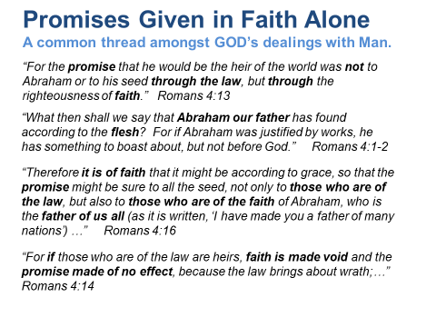

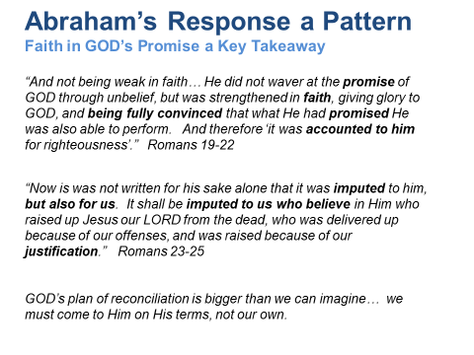

Don’t neglect GOD’s plan.

Why is this so important?

If we come to GOD on the basis of the Law:

* The only result can be wrath.
* We must be perfect on the basis of our own merit.
* We fall into the trap of attempting to rely upon our own merit and not His.

The Law cannot be the means of earning what is freely given.

